Test Case: tc001_SPX_Dev5_Crear_Solicitud_Articulo_Almacen
Step 1 - Enter username and password and click to button Enter : Credentials Entered
Image file-name: QC_Testing-tc001_SPX_Dev5_Crear_Solicitud_Articulo_Almacen-1787940836909

Step 2 - Select to UEN and Access to Request for a New Inventory Item : UEN Correctly selected and Correct access
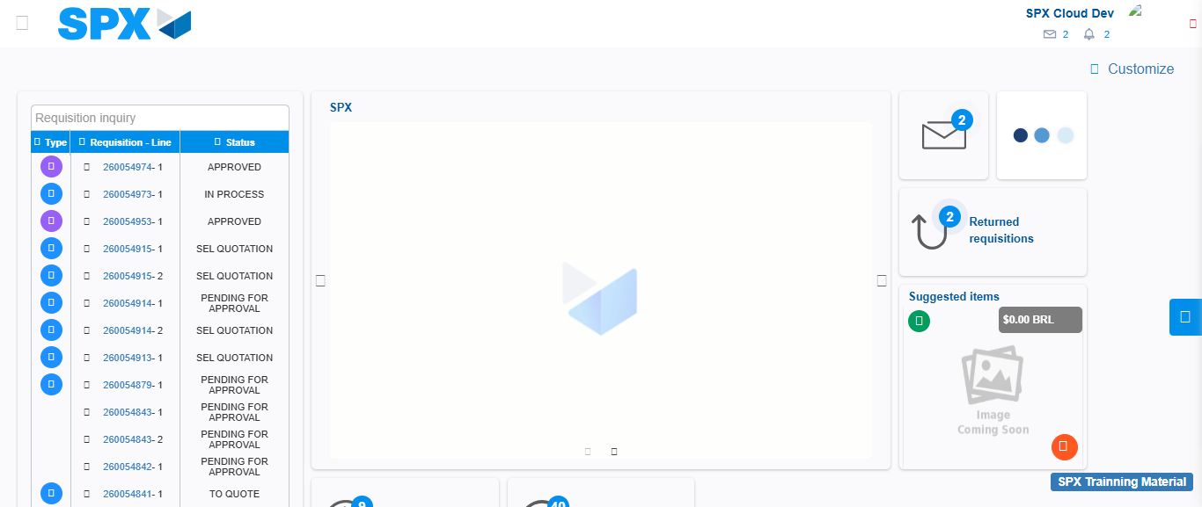Image file-name: QC_Testing-tc001_SPX_Dev5_Crear_Solicitud_Articulo_Almacen-1787940867587

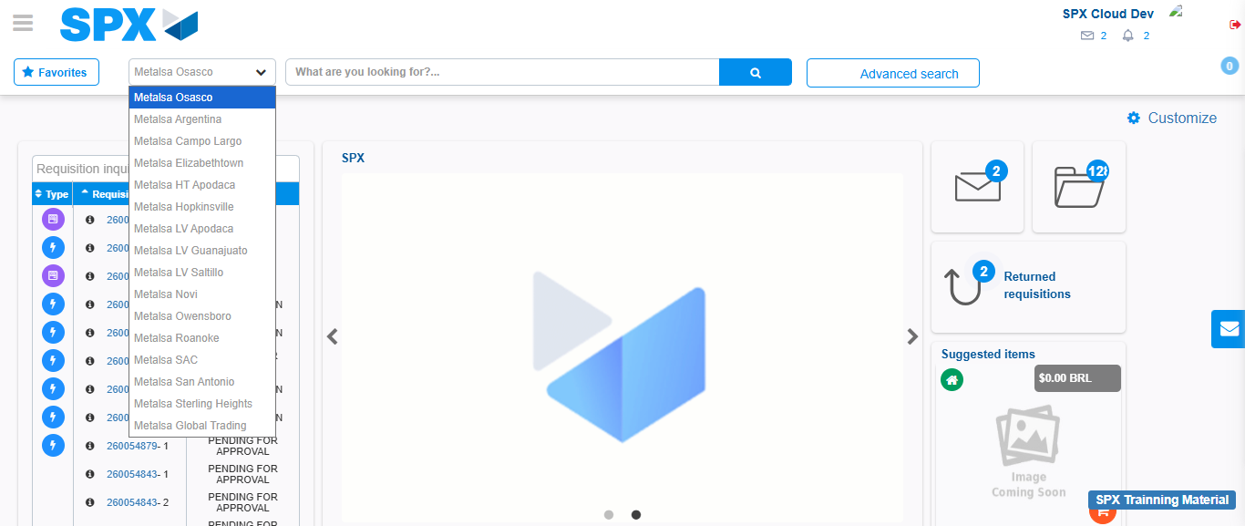Image file-name: QC_Testing-tc001_SPX_Dev5_Crear_Solicitud_Articulo_Almacen-1787940872756

Image file-name: QC_Testing-tc001_SPX_Dev5_Crear_Solicitud_Articulo_Almacen-1787940887699

Step 3 - Select options first section : Options seleted correctly
Image file-name: QC_Testing-tc001_SPX_Dev5_Crear_Solicitud_Articulo_Almacen-1787940887955

Image file-name: QC_Testing-tc001_SPX_Dev5_Crear_Solicitud_Articulo_Almacen-1787940888121

Step 4 - Select options at Screen: Options seleted correctly
Image file-name: QC_Testing-tc001_SPX_Dev5_Crear_Solicitud_Articulo_Almacen-1787940887955

Image file-name: QC_Testing-tc001_SPX_Dev5_Crear_Solicitud_Articulo_Almacen-1787940888121

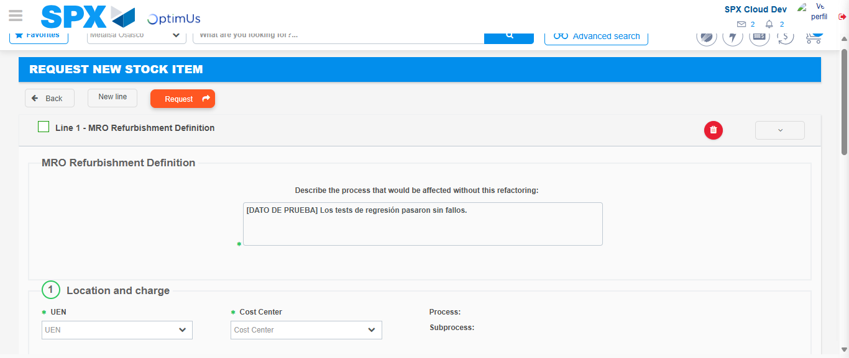Image file-name: QC_Testing-tc001_SPX_Dev5_Crear_Solicitud_Articulo_Almacen-1787940899108

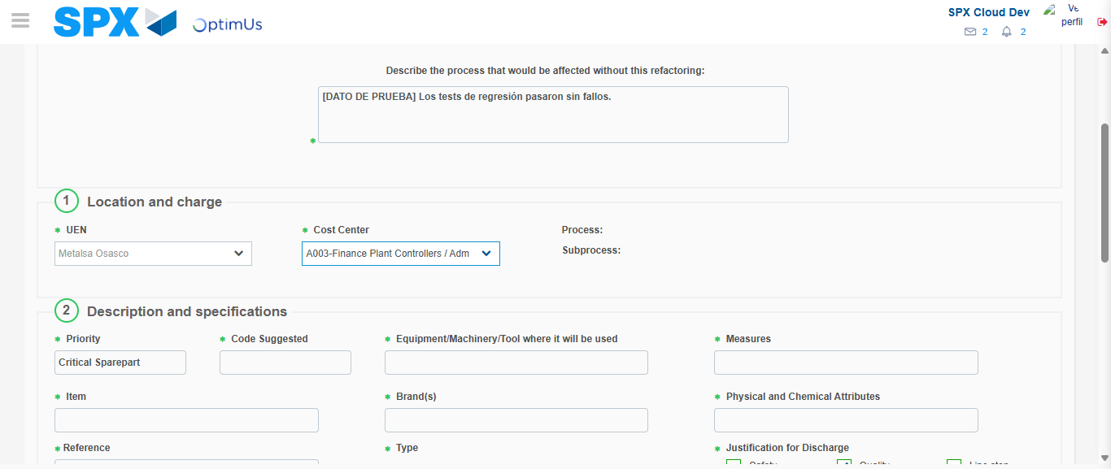Image file-name: QC_Testing-tc001_SPX_Dev5_Crear_Solicitud_Articulo_Almacen-1787940901499

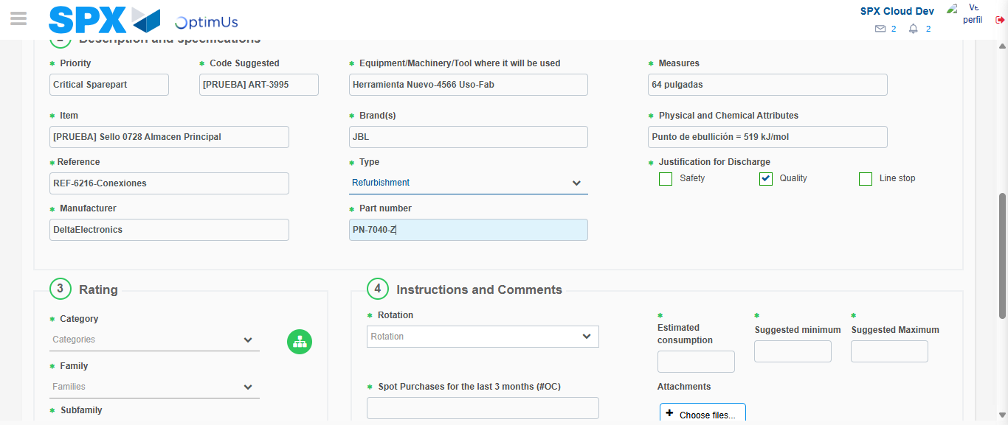Image file-name: QC_Testing-tc001_SPX_Dev5_Crear_Solicitud_Articulo_Almacen-1787940902748

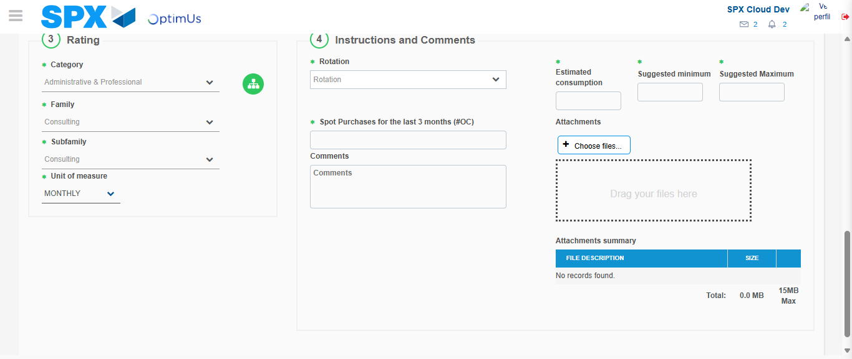Image file-name: QC_Testing-tc001_SPX_Dev5_Crear_Solicitud_Articulo_Almacen-1787940906784

Step 5 - Request New Item : Request Accepted
Image file-name: QC_Testing-tc001_SPX_Dev5_Crear_Solicitud_Articulo_Almacen-1787940867587

Image file-name: QC_Testing-tc001_SPX_Dev5_Crear_Solicitud_Articulo_Almacen-1787940872756

Image file-name: QC_Testing-tc001_SPX_Dev5_Crear_Solicitud_Articulo_Almacen-1787940887699

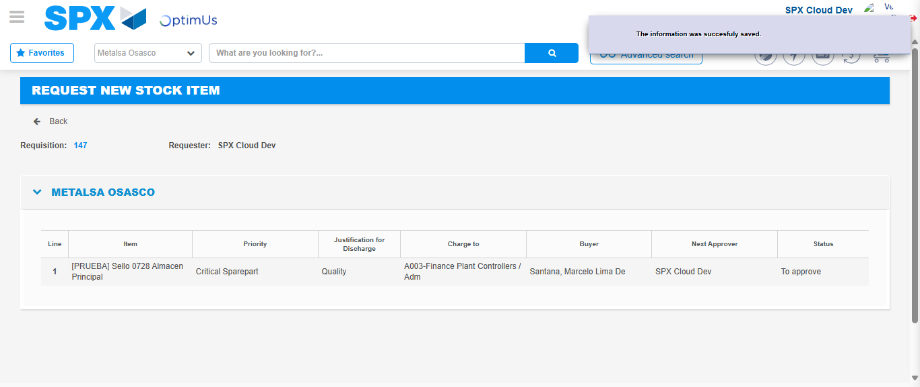Image file-name: QC_Testing-tc001_SPX_Dev5_Crear_Solicitud_Articulo_Almacen-1787940913210

Image file-name: QC_Testing-tc001_SPX_Dev5_Crear_Solicitud_Articulo_Almacen-1787940913382

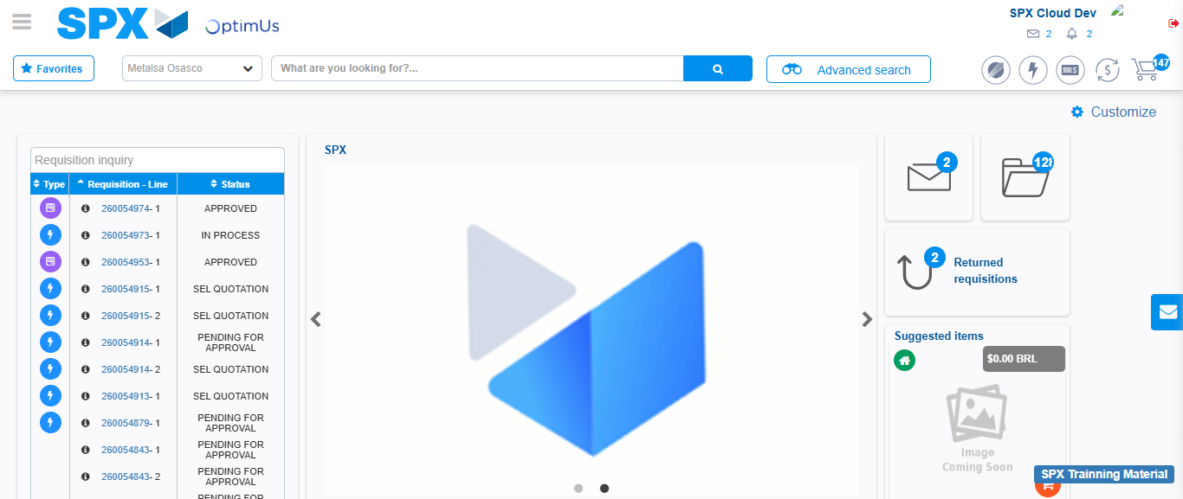Image file-name: QC_Testing-tc001_SPX_Dev5_Crear_Solicitud_Articulo_Almacen-1787940934509

Step 7 - Return to Main Page SPX : Return to Main Page SPX
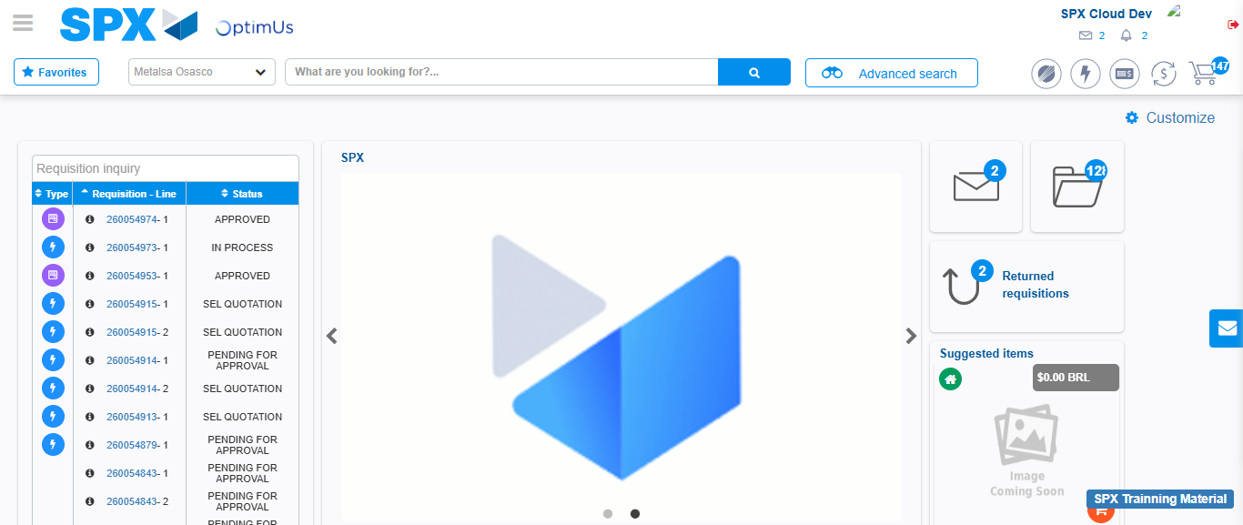Image file-name: QC_Testing-tc001_SPX_Dev5_Crear_Solicitud_Articulo_Almacen-1787940934791

